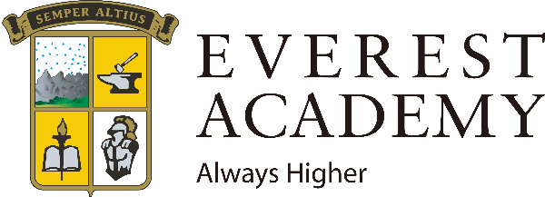

**Holistic English Immersion Kindergarten & Elementary Education**



Integral Formation (교육방식) 통합적 양성



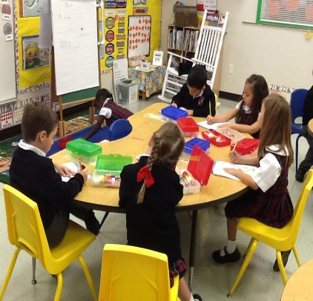



🡪Virtue Class

🡪Family Atmosphere

🡪Presentation Skills

🡪English Skills

🡪Content Knowledge

🡪Critical Thinking



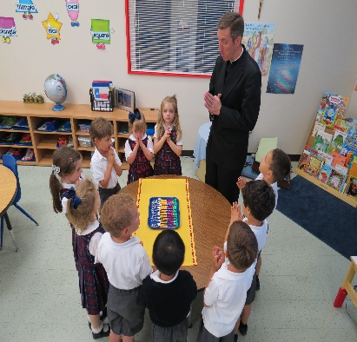

🡪Writing Letters for Elders at a Nursing Home

🡪Helping Others

🡪Caring for the Environment

🡪Prayer

🡪Religion Class

🡪In School Priest

At Everest Academy, students learn English naturally through authentic experiences and activities. They learn in a comfortable, family like atmosphere. Our four areas of formation educate students not only to be fluent English speakers, but also leaders in society.

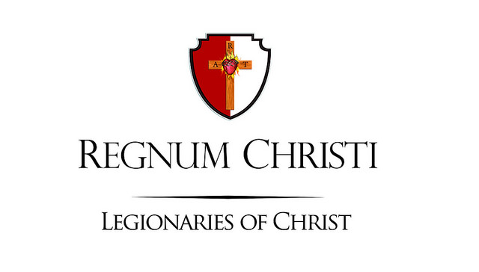

**Everest Academy Korea**

We are a school under the Catholic Movement of Regnum Christi’s

RC Education Department. We are a

**Korean Catholic English Academy.**

We offer full day instruction for students 5 years old to 7 years old, and after school English classes for Elementary school students. We opened our doors in March 2017.

Our Educational philosophy centers around four areas of formation: Intellectual, Human, Apostolic and Spiritual.

Our curriculum is based on the Common Core and RC Education standards, and ensures students learn in a holistic way. At Everest Korea, we have modified these curriculums to meet the needs of language learners and center our instruction around themed units. Students learn key skills around those themes.

Our mission is: *to teach, to form, and to educate.* We aim for more than English fluency. We help students become good and happy people who can help others in the future.

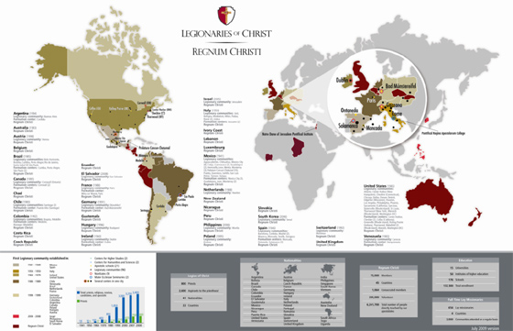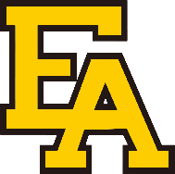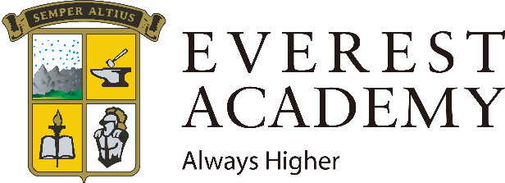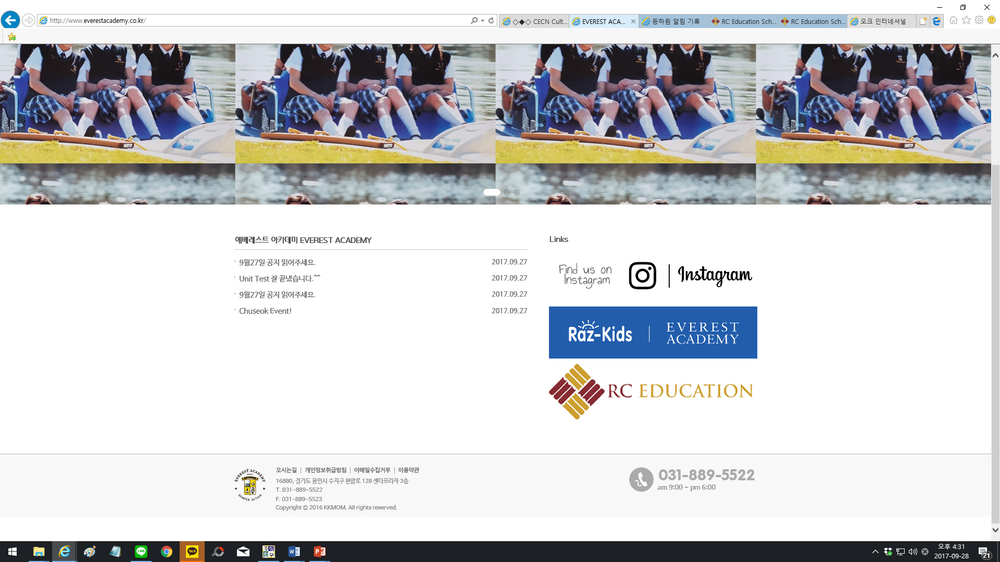

Regnum Christi was established in 1941 by the Vatican in Rome. Regnum Christi is located worldwide in over 22 countries. Regnum Christi is made up of priests, consecrated women and men, and lay members all working towards the mission of evangelization. They have over 180 schools worldwide, including 15 universities. All of the schools use Integral Formation as their main philosophy.

**Network of Regnum Christi**

Homepage: http://www.everestacademy.co.kr

Blog: http://blog.naver.com/everestacademy

Instagram: http://www.instagram.com/everestacademy.korea