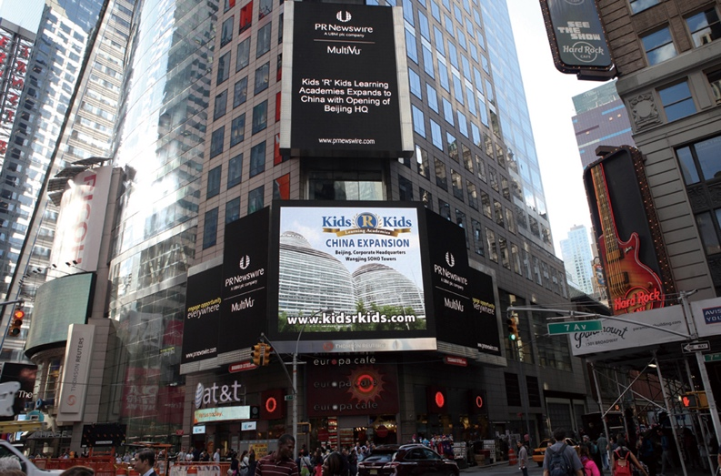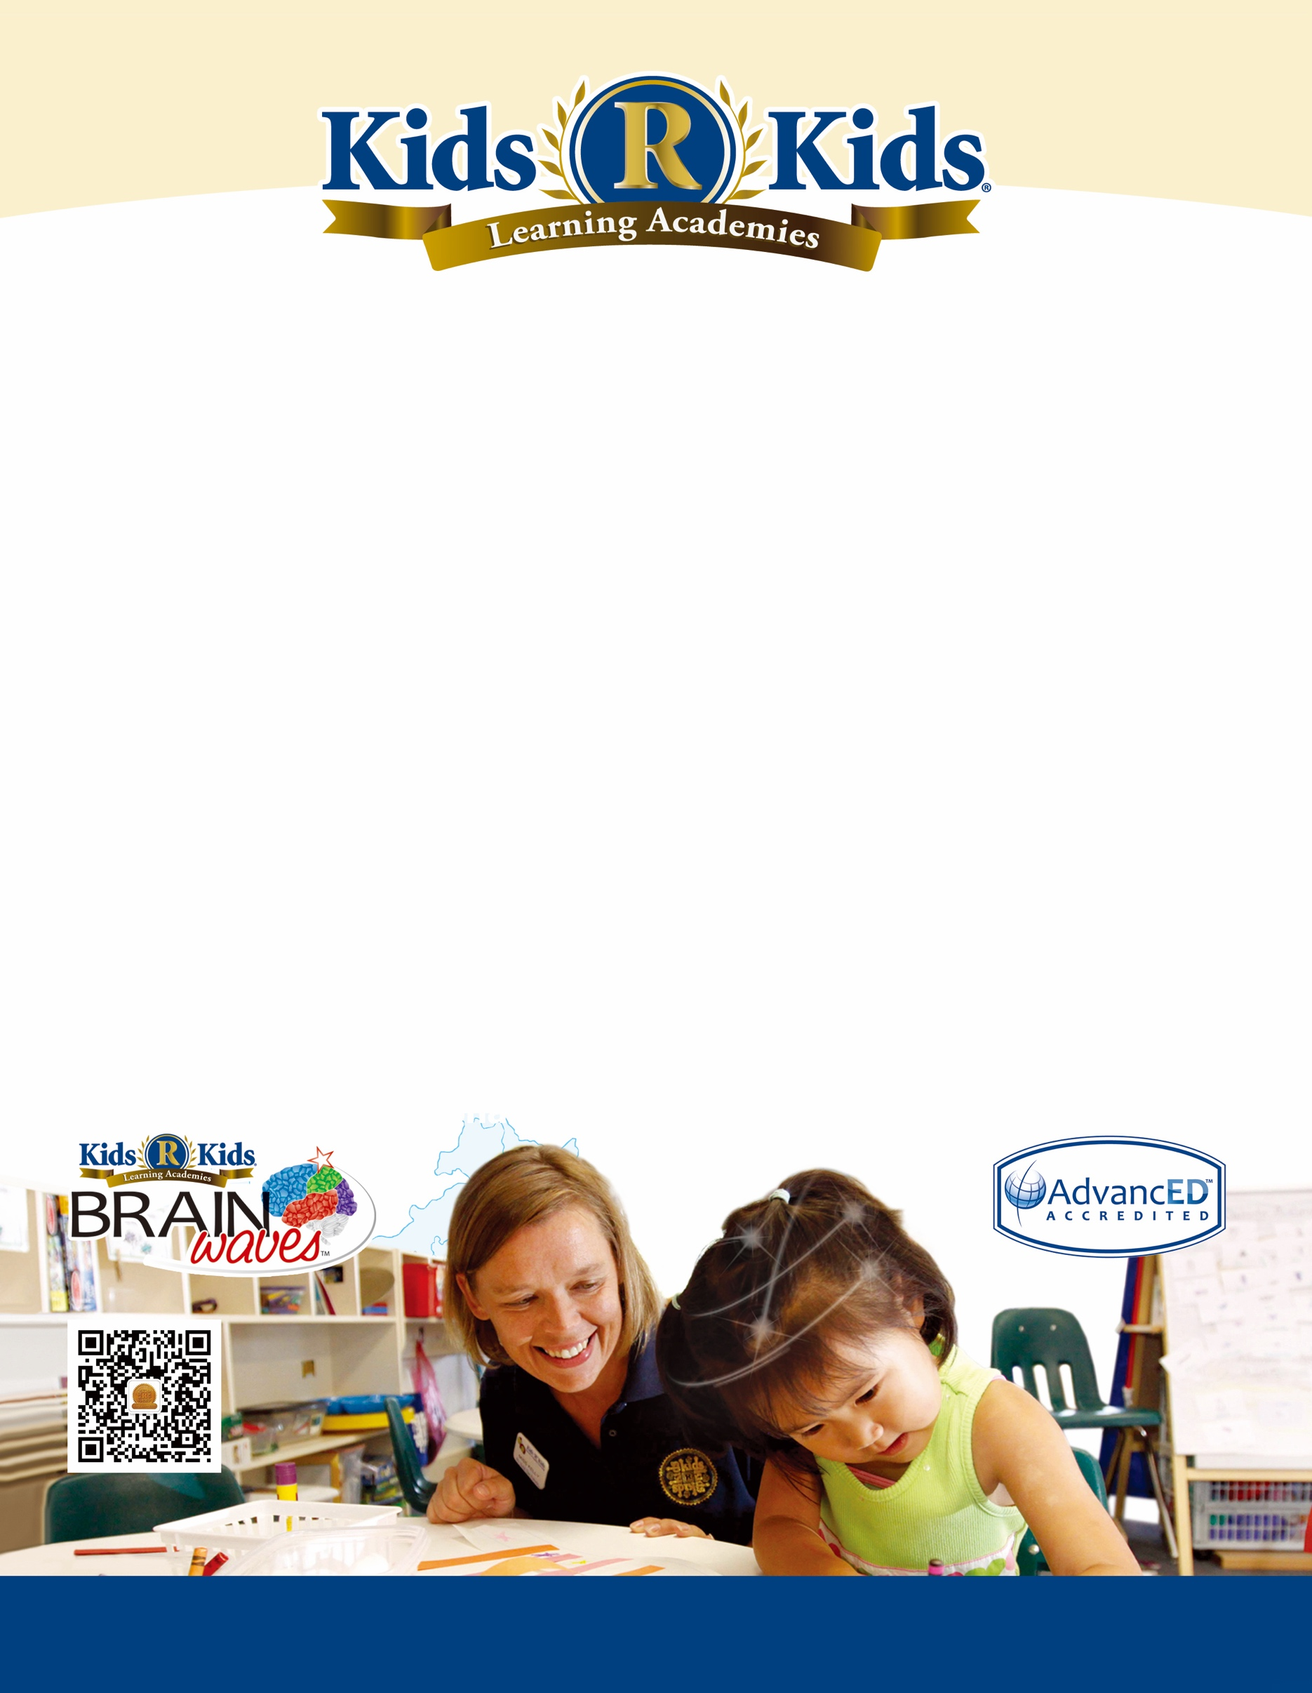

**Kids 'R' Kids Learning Academies Opening in Beijing, Shanghai, Nanjing, Tianjin, Guangzhou, Suzhou, Jinan, Changsha, and Dalian in 2018**

**Kids ‘R’ Kids Tianjin**

**New York Time Square**



|  |  |  |  |
| --- | --- | --- | --- |
|  |  |  |  |
| Tel (USA) | : +1 770-654-6461 | Email | : crystal@kidsrkidschina.com |
| Skype ID | : Crystal_Rhodes | Website | : www.kidsrkidschina.com www.kidsrkids.com |

**Kids ‘R’ Kids Learning Academies Opening in China**

**Kids ‘R’ Kids** Learning Academies provide a secure, nurturing, and educational environment for children; a place for children to grow into responsible, considerate and contributing members of society.

With more than 160 learning academies in over 14 states in the U.S., Kids ‘R’ Kids is expanding its AdvancED accredited education system into China.

You can be assured, in working with us, we will be your partners in helping build a meaningful and successful career.

Beijing, Shanghai, Tianjin, Guangzhou, Nanjing, Suzhou, Changsha, Dalian, Jinan and other cities in China.

1. Open-minded and service-oriented
2. Four-year degree in early childhood education or related area
3. Working knowledge of the behaviors and developmental stages of infant / toddler / pre-school age children, typically gained by working three years or more in a school or preschool setting
4. Knowledge of safety practices as they relate to infant / toddler / preschool age children
5. English native speaker with good written and oral communications skills in English is mandatory
6. Infant, Child and Adult CPR/First Aid certified
7. Employment conditional upon results of the following:

* Satisfactory criminal background check for child care centers and Satisfactory Drug Screen

|  |  |
| --- | --- |
| **Position:** | **English Teacher of**  **Kids ‘R’ Kids Learning Academy** |

**Preferred Qualifications:**

1. Learn and administer the appropriate curriculum for children in your care for both classroom and outdoor activities, in accordance with age appropriate objectives, developmentally appropriate practice and program philosophy of “Hug First, Then Teach”
2. Collaborate with Chinese Teachers to maintain all appropriate daily records and daily update communication with families of children in your care
3. Maintain confidentiality with information shared by owner, administration, teachers, staff and families
4. Report any suspected child abuse to owner or administrator. You are a mandated reporter
5. Assess and record progress in all areas of growth for children in your care. This includes physical, cognitive, social and emotional growth
6. Document incidents and accidents appropriately for the administrators’ approval
7. Work with Chinese staff to arrange the classroom environment in accordance to program goals
8. Meet all Quality Assurance and Education Best Practice Guidelines. Stay current on and meet all licensing regulations

**Locations:**

**Responsibilities:**