Full-time Office-based English Teachers
Xue Bang Education is an online teaching platform focused on oral English. Students age from 5 to 18. Many students are from 2nd and 3rd tier cities who seldom have the chance to communicate and study English with certified/professional teachers. To support our equal learning opportunity mission, we are seeking native English speakers for our program.
To Apply： send your resume to felicity.zhang@xuebangonline.com
Location:
Beijing Office:
Beijing Rm8-6, Tower B, SOHO3Q, Central Business Center, Chaoyang District, Beijing, PRC
Tianjin Office:
Huaxia Financial Center, Central Business Center, Haibin New District, Tianjin, PRC
Qingdao Office and Suzhou Office are being arranged positively.
Online teaching position open（ Part time only）
Requirements & Qualifications:
· Native English speaker (UK, USA, Canada, Australia, Ireland, New Zealand, South Africa)
· BA degree or above
· Passion for online teaching, and enjoy working in office setting environment
· Competent communication skills
· Outgoing, enthusiastic, and interactive
· 2+ years of teaching experience preferred (TEFL/TESOL/CELTA Preferred);

Compensation Package:
Base Salary: 16,000rmb-25,000rmb per month - Based on experience and performance in interview
Online Position: 80-150rmb/ hour
Benefits:
For Beijing Office and Tianjin Office
      - Paid holidays. 5 days for annual leave and 3 days for paid leave. Also have 6 days for sick leave.
      - Attendance Bonus up to 3500 RMB per month.
      - Loyalty bonus for extra one-month salary, if work for us for one year
      - Class incentive for office based teacher-min of 50 rmb/ Class if you have more than 40 classes a week
      - Flight reimbursement for individuals coming from abroad;(3000 rmb per person)
      - Z visa provided(working visa)
      - Professional TOSEL/TEFL/CELTA training;
      - Elegant Working Environment and the teaching material were provided by us;
      - On-going professional teacher development and training programs;
      - Chinese language classes (2 hours per week);
      - Team building activities and birthday parties etc.
Special benefit for Tianjin Office ONLY:
Company accommodation! (Furnished 2 bedroom or 3 bedroom)
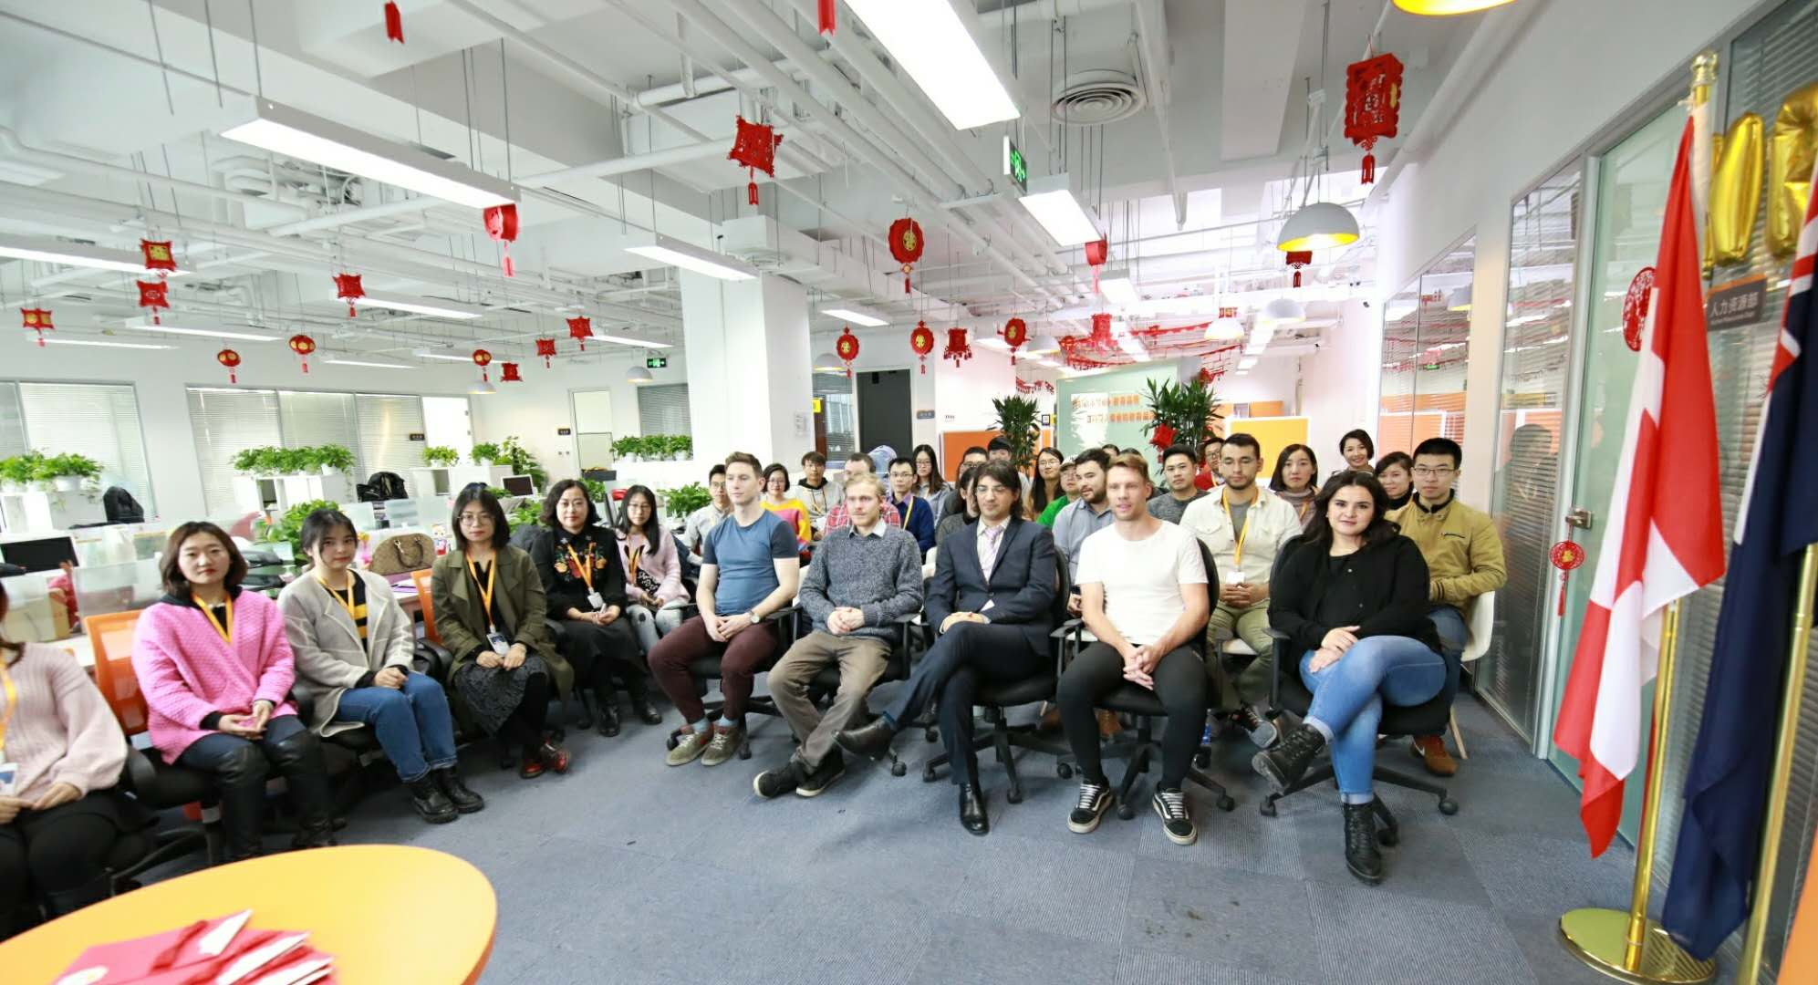
New Year Party 2017
Team Outing-2017
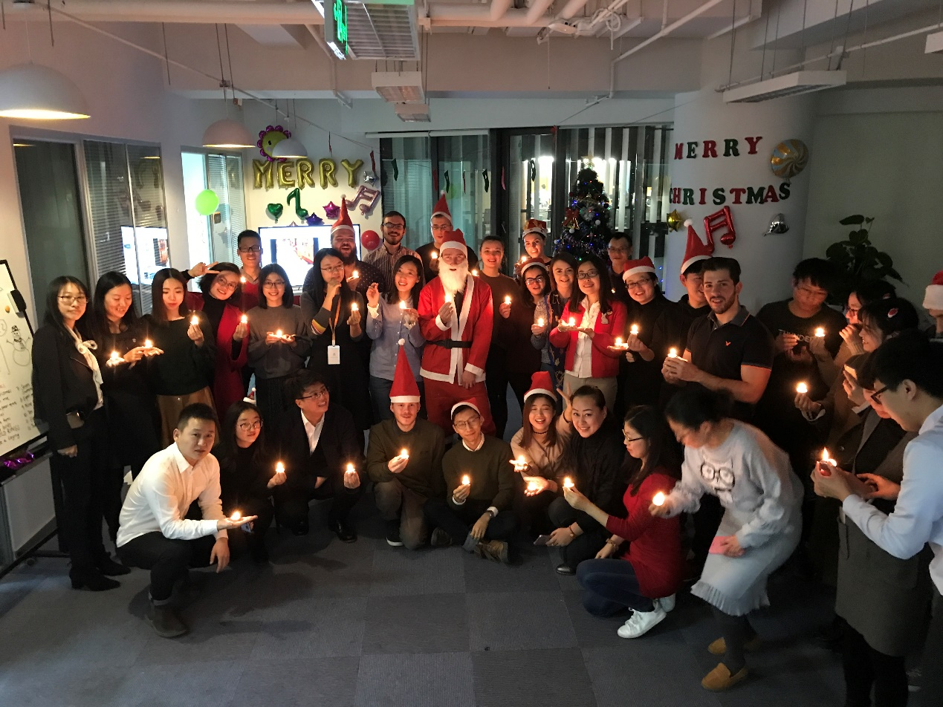
Merry Christmas Party-2017
Working Time
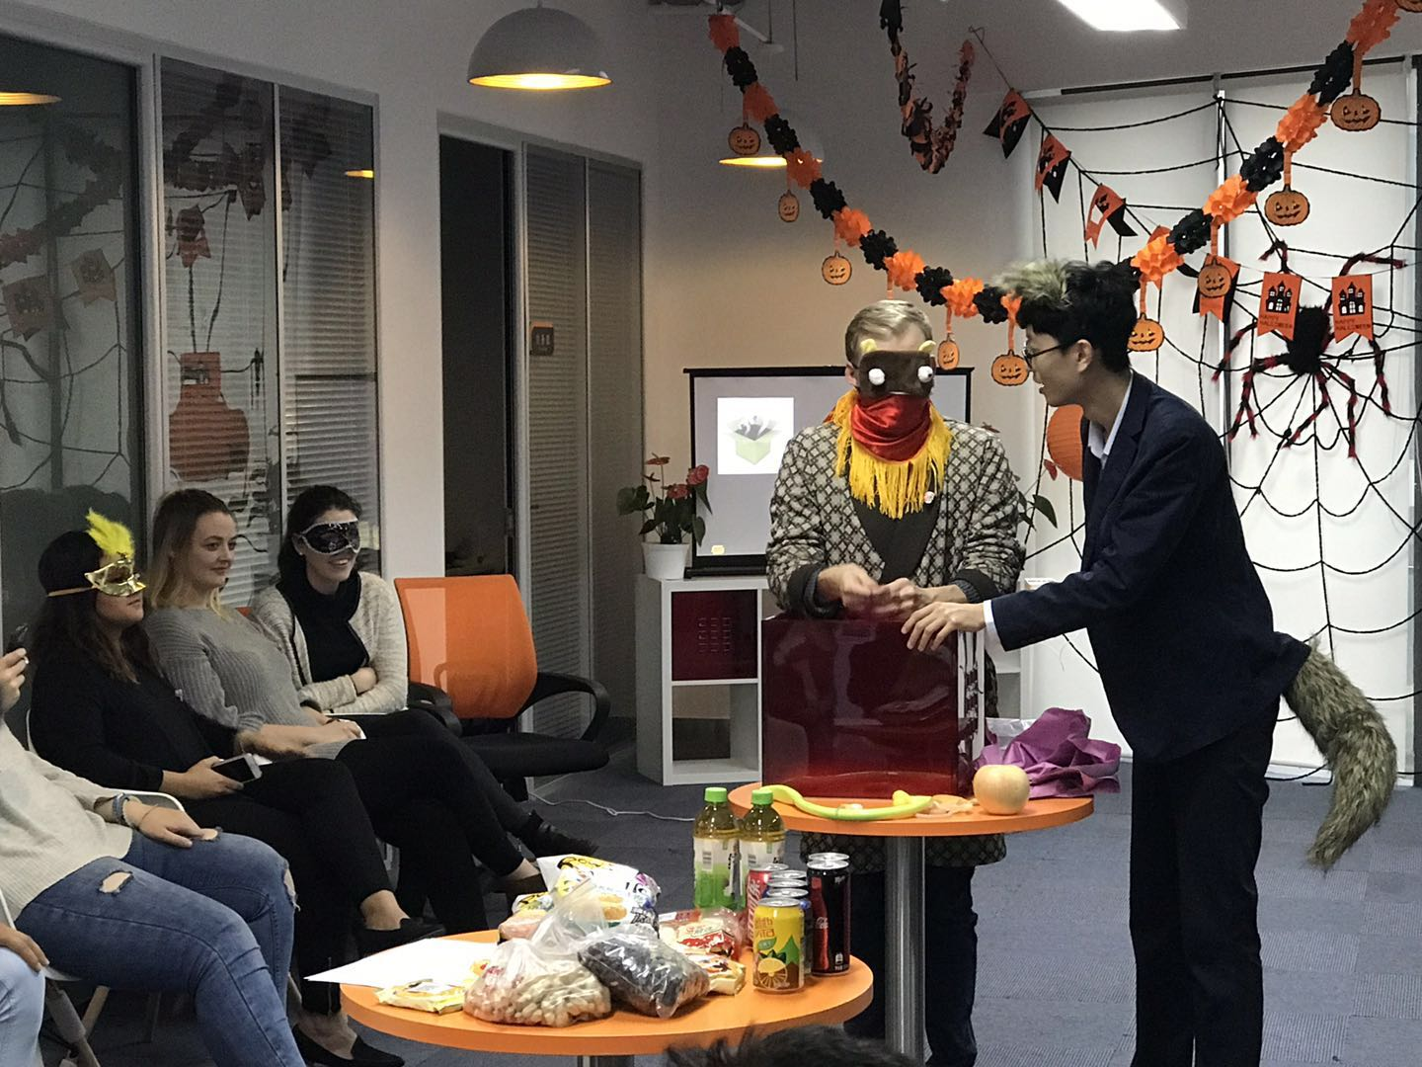
Happy Halloween Party-2017
Company Outing in Datong-2018

