Yearbook

2018 – 2019

Academic and Community Involvement Update

To Faro Friends,
We want to thank you once again for your continued support and dedication to this project. It’s been my pleasure to help in the growth and advancement of the school and I look forward to next year! Please check out our Instagram and fb page and also our new website at farodecabrera.squarespace.com to see updates on the school at farodecabrera.squarespace.com .

Sincerely,

LibbyFurcolo

Academic Coordinator, Director

farodecabrera@gmail.com

FaroDeCabrera website
809-589-7090

Contents

Academic Overview
Growth – Reach – Groupings – Course Work – Curriculum/Accreditation
Extra-curricular

Community Involvement

Volunteer Opportunities

Thank You’s
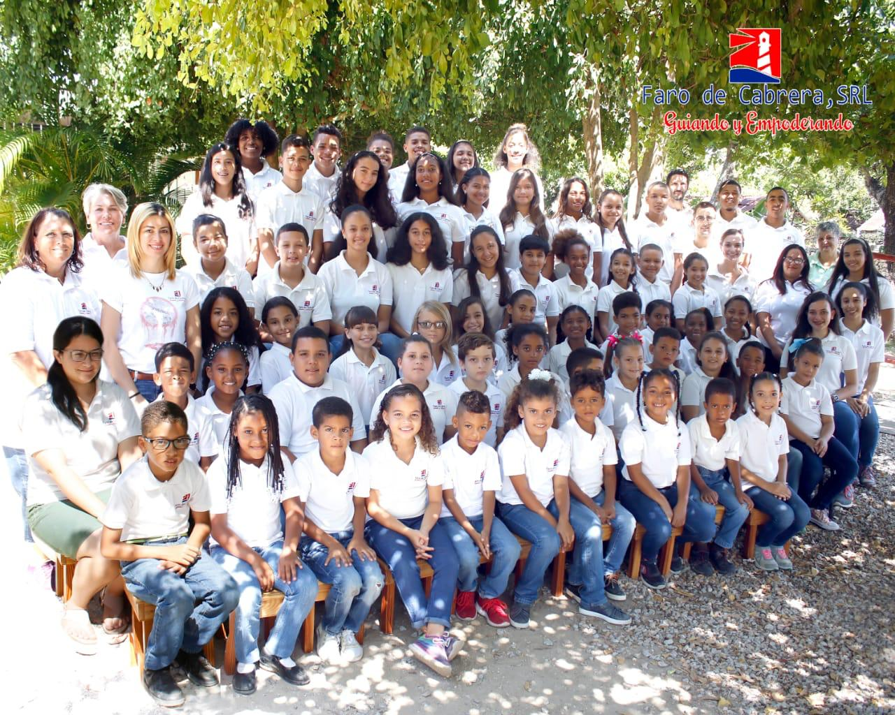

Academic Overview

El Faro de Cabrera and affiliates believe that true education is not simply the acquisition of knowledge but also the wisdom of knowing what to do with it. We believe in cultivating a community of life-long learners that will investigate, evaluate, and take responsibility for the world around us. El Faro de Cabrera offers a full-day, bilingual curriculum (English/Spanish) for grades Kindergarten-12. Our educational model uses integrated studies, project based learning, as well as traditional structures to give our students a wide variety of educational experiences and opportunities that will prepare them for a future both locally and abroad.

Growth - For the past 5 years, we have been focusing our efforts on growing our student body, expanding our academic team, and solidifying our organizational structure. We have been partnering with various foundations that supplement our budget to offer more economically feasible tuitions and financial aid opportunities to the local community. We have gone from 15 to 23 to 34 to 63 and are looking at approximately 100 students for 2019/2020! We are so very thankful for our dedicated sponsors, families, and staff that have made this dream become a reality! While 100% of our students are benefitted in some way by the school’s general fundraising, more than 50% of our families this year were involved in financial aid programs for their studies.

Reach - The majority of our students are local Dominicans. We have students coming from the surrounding areas like Rio San Juan, Abreu, Cabrera, and La Entrada, but we also have a number of seasonal students that come from abroad and temporarily enroll with us while their family is visiting, vacationing, or working here in the area.

Groupings – We combine grades into learning-groups depending upon age and class size to give students a low student/teacher ratio while maintaining a solid group of peers with which to learn and develop. This structure is interesting in that it fosters more cross-curriculum unification and allows us to meet the needs of both struggling and advanced learners by being able to utilize flexible small group pairings across grade levels. This past year we had the following groupings: 1st/2nd : 14 students; 3rd/4th : 10 students; 4th/5th 11 students, 5th/6th: 8 students, 7th/8th: 10 students, 9th/10th:7 students, 11th/12th: 3 students.

Courses – Our students received English Language Arts, Math, Science, and Social Studies classes in an Immersion English setting, and received Social Studies and Spanish Language Arts in an Immersion Spanish setting.

Curriculum/Accreditation –Home Life Academy approves our standards and materials, audits and tracks students’ credits, and provides official apostilled documentation that is accepted both locally and internationally. Our teachers are given the professional freedom to really tailor the educational experience to our student’s needs. The standards we use are in line with U.S. and Dominican national standards and our base curriculum plan requires all of the suggested course material for a student wishing to go on to a 4-year university after high-school graduation.

Teachers, Staff, and Volunteers – This year, we had a teaching staff of 9, an Administrative Secretary and Academic Coordinator, a Chef and Housekeeper. Our teachers represented a wonderful diversity from all over and also we now currently have 4 teachers from the Dominican Republic to help us maintain more stability. Our volunteers consisted of parents, members of the Cabrera community, and also our teachers who dedicated their time and expertise.

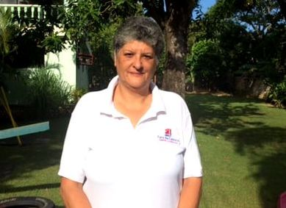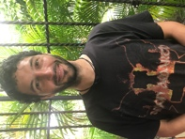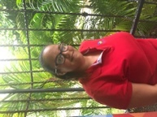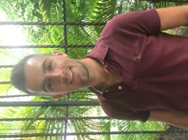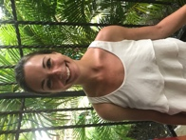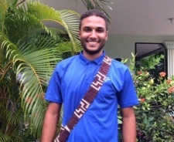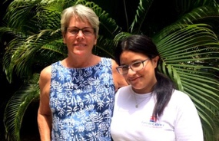

Extra-curricular

Orchid Bay Beach Clean-Up Our 3rd/4th and 4th/5th classes took an afternoon once a month to pick up trash at our local Orchid Bay beach. They counted and sorted all of the trash adding their total trash collected for the year to be approximately for the year to be 3,980 items!
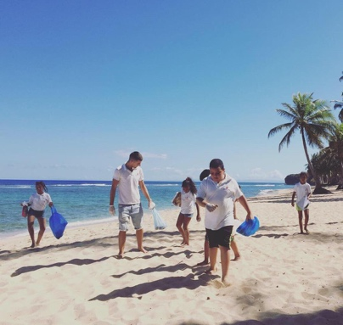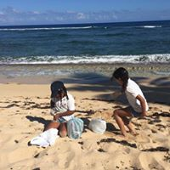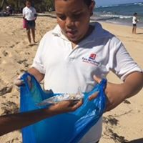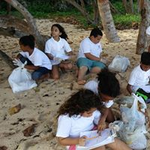

River Clean-UP Upper level students and the student Council organized a river clean-up to pick up trash along the banks of the Tio Marcos. They collaborated with schools in Abreu, Alcaldia, and Liceo Miguel Yangueia.

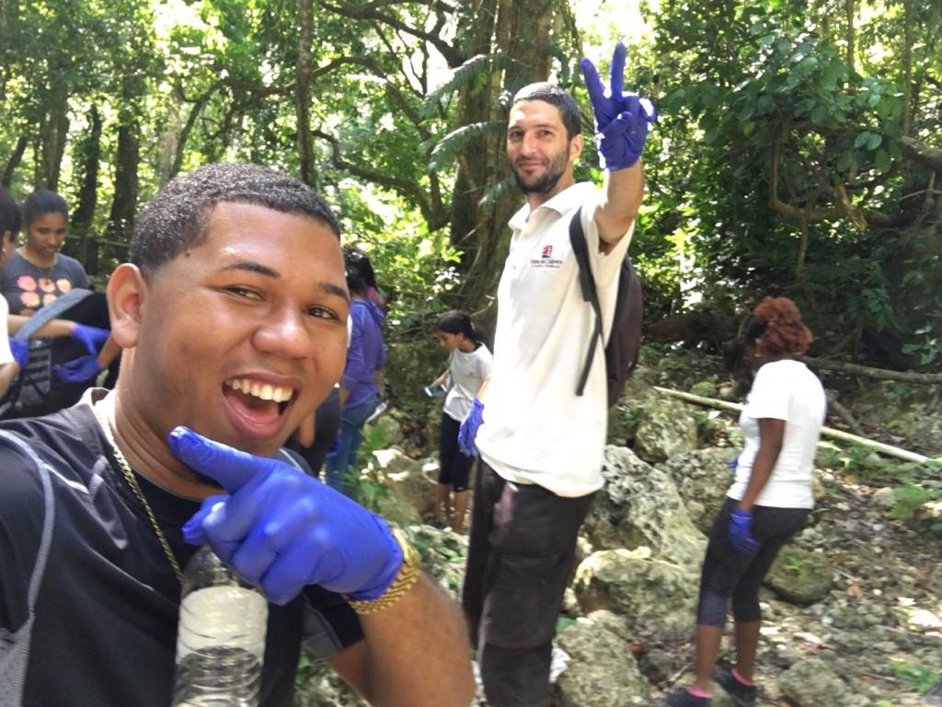

Girls’ Soccer Team Ekain, our high school Math/Science teacher, started an after school girls’ soccer team
Which ended up being co-ed because the students were so excited to have such a great extra-curricular activity!

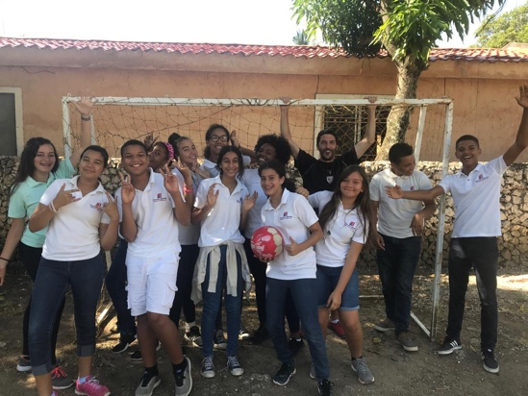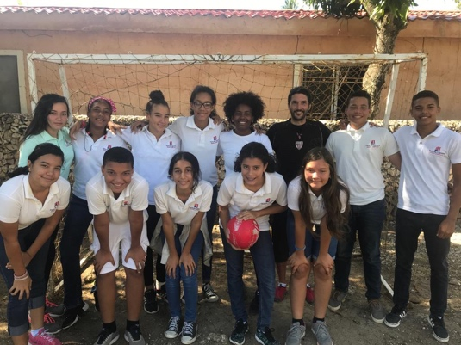
Community Dance Classes Miss Dayna, our 3rd/4th grade teacher, volunteered her time to teach a free community modern dance class at ProForma Gym. The school supported her by paying for3 months rental at the gym but it was so popular that they ended up donating the space for the rest of the year! Some of the students also performed for a Mothers’ Day recital.

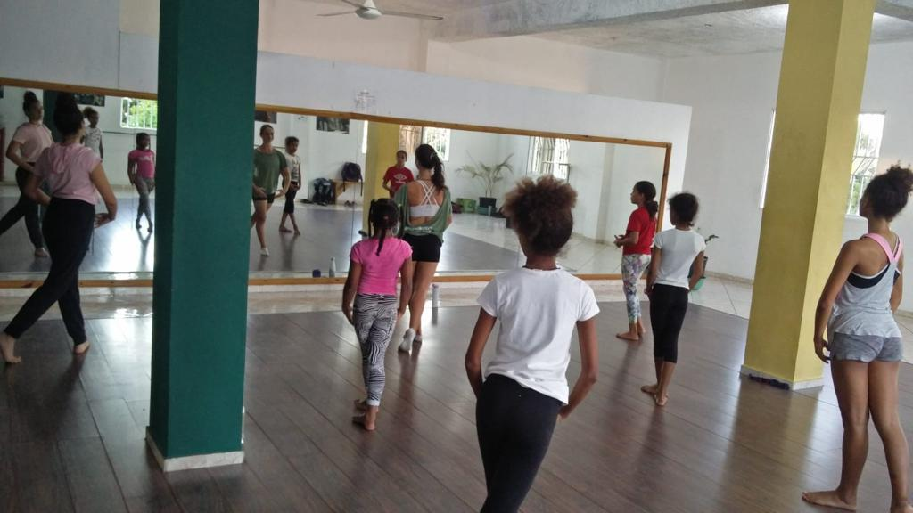

Field Trips This year, Faro did a whole school unit on bees, aquaculture and permaculture and how they are all connected in using our local resources to grow food sustainably. We made 2 trips to Taino Farm, one with our elementary students and one without high school students. The students divided into three different groups to do hands on activities relating to bees, aquaculture and permaculture. Afterwards they were able to enjoy a locally grown organic and vegetarian meal from the farm!

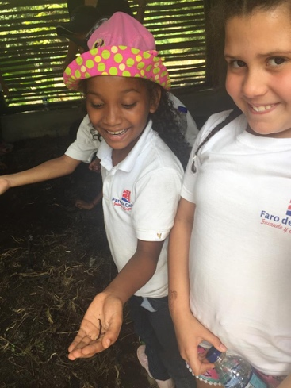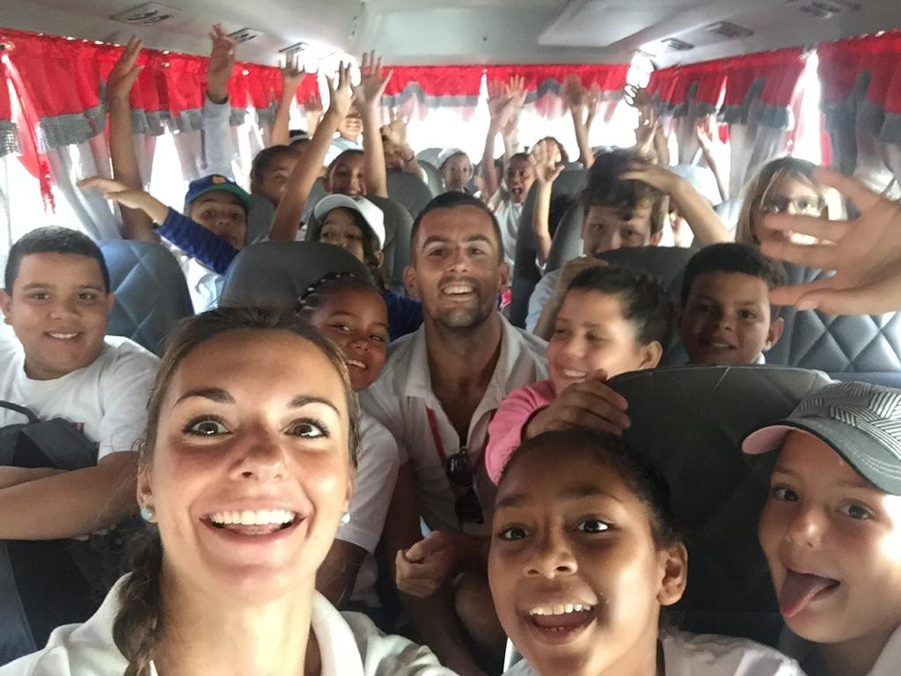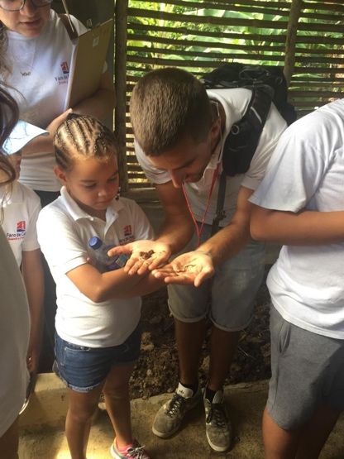

Community Involvement Overview

Faro believes in investing in our community as well as in our students. Our teachers have supported and volunteered with a number of organizations that are active within our community such as Protección Animal Cabrera and INAPA. Reaching out and supporting fellow organizations allows us to be involved in educational opportunities outside of our school’s walls and build relationships with youth and professionals throughout the community and surrounding areas.

Getting Involved

Paid Teaching Positions: Wanting to teach? Contact us to see if there are any positions available!

Special Programs: Faro is always looking for volunteers willing to work with us to develop special programs and extra-curricular activities. Your expertise, special interests, or hobbies can be turned into a class or workshop and be put to go use in the community around you!

Substitute Teachers: We are always in need of people to call upon should one of our teachers or staff fall ill. Fundraising/Donations: Visit our webpage to see a Wish List of supplies or to donate to our Faro Scholarship Fund.

Thank You’s!

We are enormously grateful for the continuous support and dedication from the following people and organizations.

Without our incredible staff, volunteers, and donors, Faro de Cabrera would not be what it is today.

Donors & Sponsors | Volunteers | Staff & Teachers
The PONA Foundation, Dan Moller and family | Dulce Ferreira | Mirian Adames
 | Carmen Guerrero | Minerva Santana Hilario
Kimball Foundation/Casa Kimball, Spencer Kimball | Victoria Hernandez | Guadalupe Ortiz
Friends of Cabrera, Monica Bouwmeester | Marta Cabrera | Ana Sanchez
 | Felicita Garcia | Soeli Garcia Guzman
Sunrise Villa, Kevin Potter  Capital Community Partners, Bruce DarConte | Birgit Hinrichsen | Jeffrey Perez
 |  | Ekain Ripa
 |  | Elizabeth Furcolo
 |  | Dayna Goldman
 |  | Christopher Lewis
Sheryl Filer
Sorieli Guzman
Linabeth Mejia

To the many others that have contributed in one way or another,

we wish you a HEARTFELT THANK YOU!

